**U-dog : For Underdogs , by Underdogs.**

**Website for gamer underdogs.**

**Name: Satnamsingh Sandhu**

**Department : CSPIT-IT**

**Email:** [**20it122@charusat.edu.in**](mailto:20it122@charusat.edu.in)

**Abstract:**

**This is a project which is made for gamers and gamer underdogs(The players who have potential and don’t get recognition). This website consists of gamer registration in various gamers. It also consists organization registration. There is also profile built of gamer and organization.**

**There is also included default payment methods included in the website. There is also included blog part in the website which is updated every week as per the progress.**

**Keywords : The name of the project is “U-dog” , with the tagline “For Underdogs , by Underdogs”. This project is made with help of HTML, CSS, JavaScript, PHP and SQL. The SQL part is yet to be executed due to lack of knowledge.**

**Introduction :**

**There are may methods like UPI, Credit/Debit Card, Net banking, etc. There is also a sign in page that can be used to sign in to your profile. There is also a blog section which contains the information about the website and future plans. The blog part is updated every week as per the progress. In the near future, we are willing to add SQL to save the data of the users and will be trying to add the streaming server to the website so that they can stream their game play to the audience. We are also planning to have a mobile application on smaller scale and then will try to extend it to national level. The goal is to have it implemented by early 2022 and expand only in Gujrat for the base level if the response is great then to extend it to national level and then to global.**

**There are may of the websites that have some or the other kind of content or recommendation or some other kind of gamer support on using there website or the application but there was no kind of support to the gamer underdogs as they are posting content on YouTube or on Instagram or on Facebook but there is no one to recognize them. So I thought to make this website so that the underdogs can get some kind of recognition or some kind of help to find some good team or some good organization to support their grind. They could also get sponsored by some of the reputed brand so that they have a better time grinding. This website contains the gamer registration of various games which we will be trying to include most of the games that are played amongst the players or amongst the community. . There is also the organization registration where the organization registers them self and can have a look at the player that are there having the potential and can support them. There is also the payment method so that there can be some kind of monetary transaction between the player to player or player to organization.**

**Methodology :**

**This work was done single handedly by me and it took around 48-52 hrs. of work to complete the website.**

**The flow of the website began with the basic frame work and basic creation of the website without any kind of CSS , JS and PHP the with use of CSS, PHP and JS the website stands where it is today.**

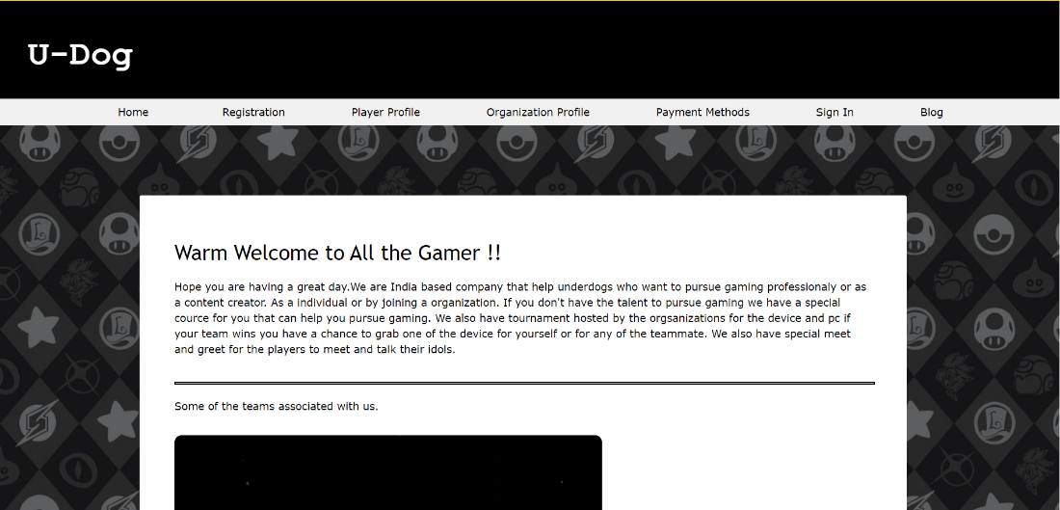

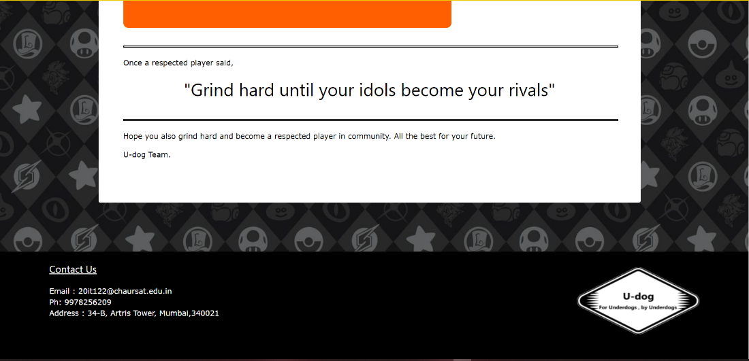

**This is what the main page of the website looks like. In the middle of the page there is the changing image that is made using java script. Other editorial work is done by the help of CSS and HTML .**

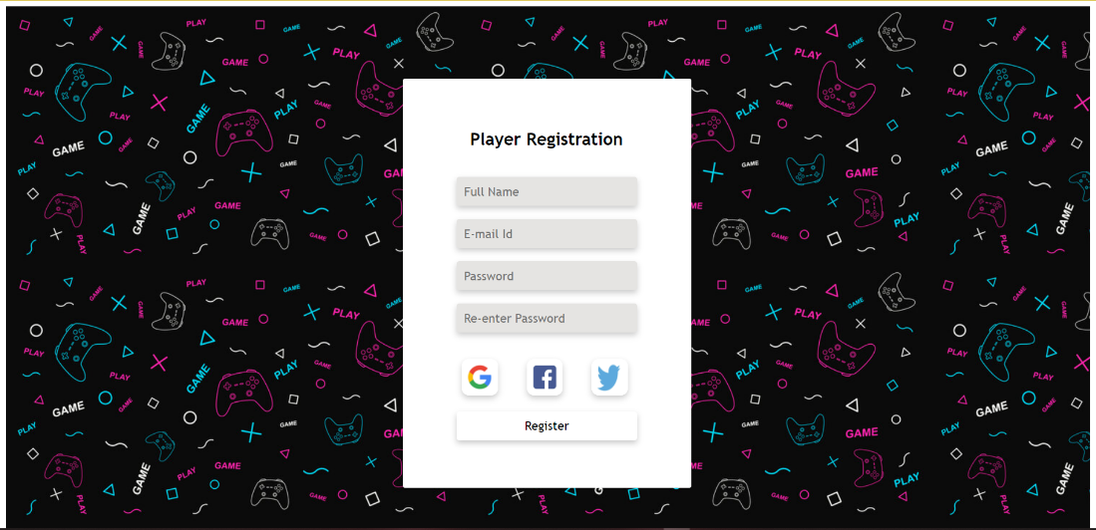

**This is what the player registration page looks like.**

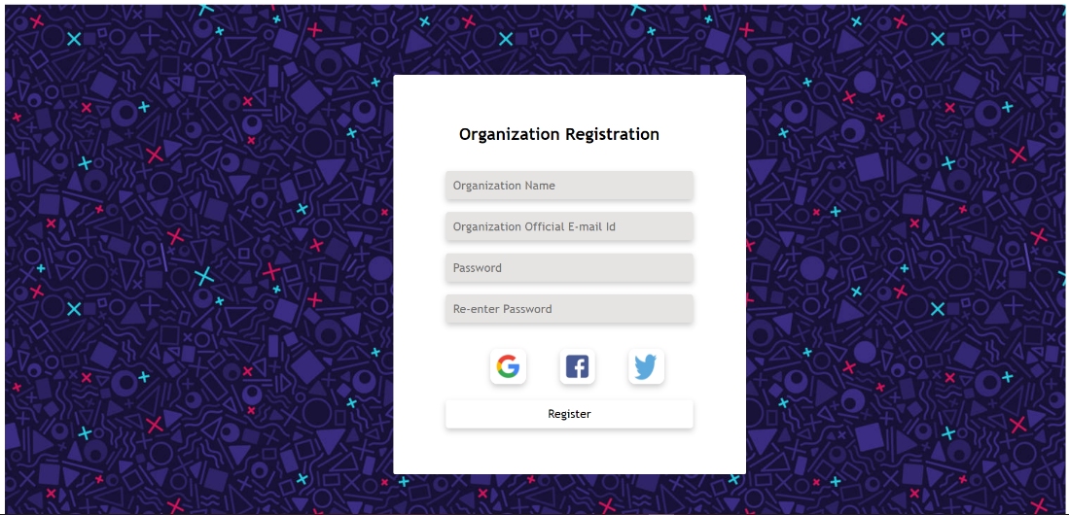

**Organization Registration Page.**

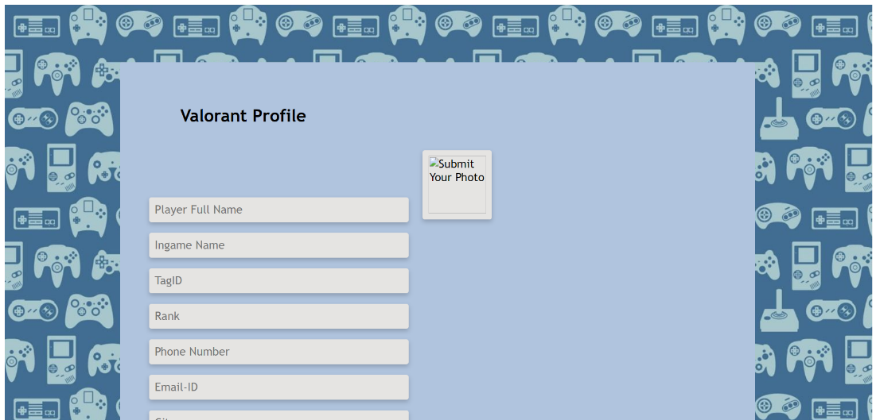

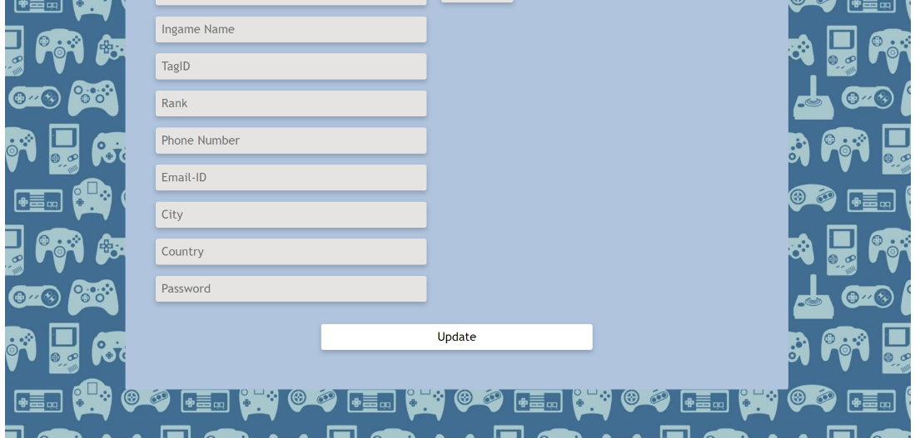

**Player Profile for Valorant Game**

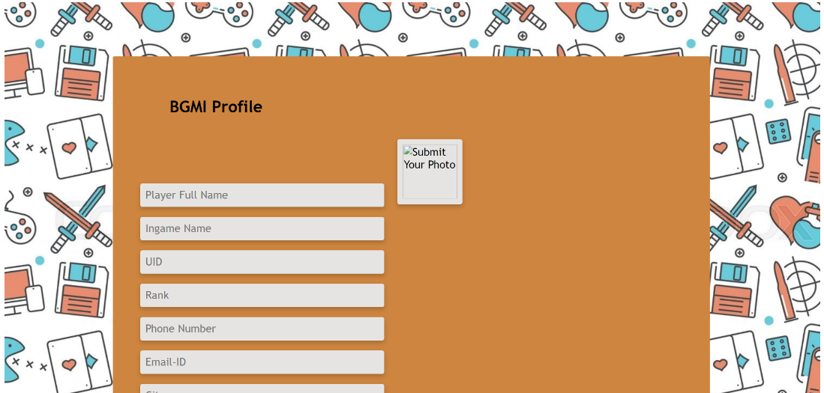



**Player Profile for BGMI Game**

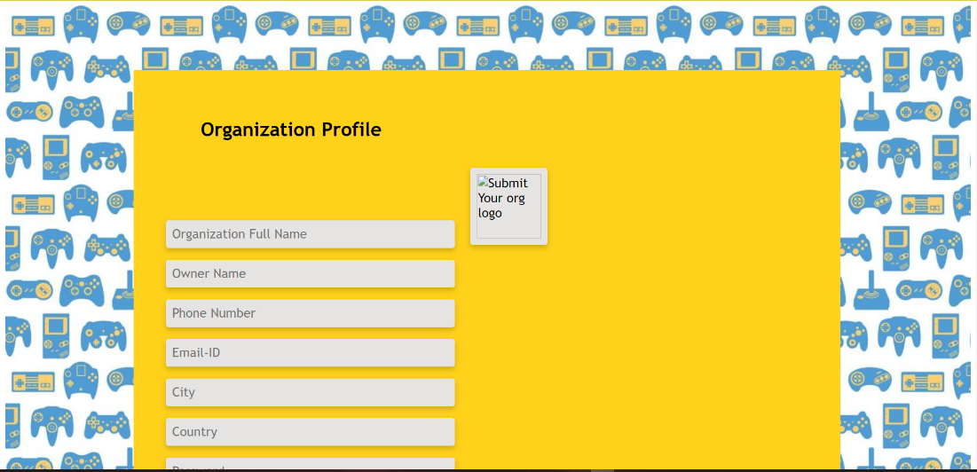

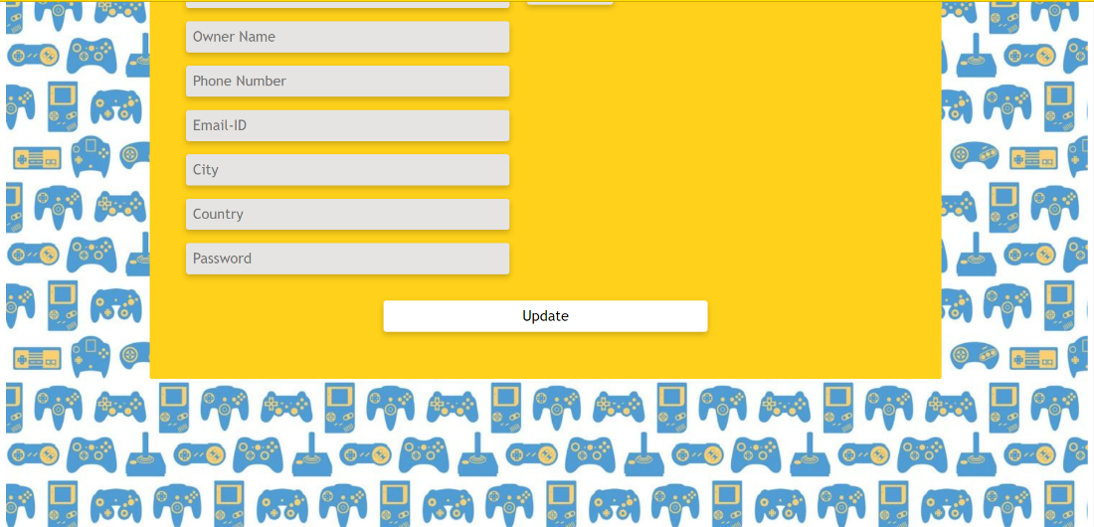

**Organization Profile**



**Payment Method Page**



**Sign In Page**

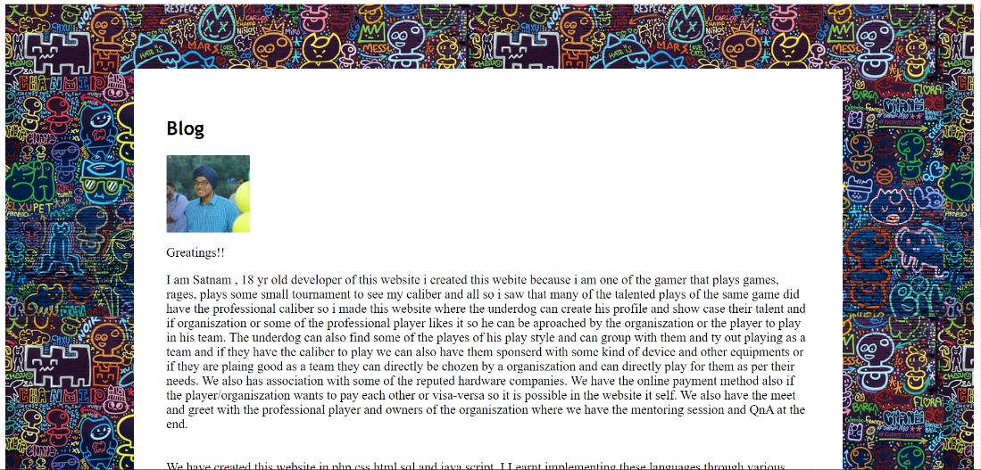

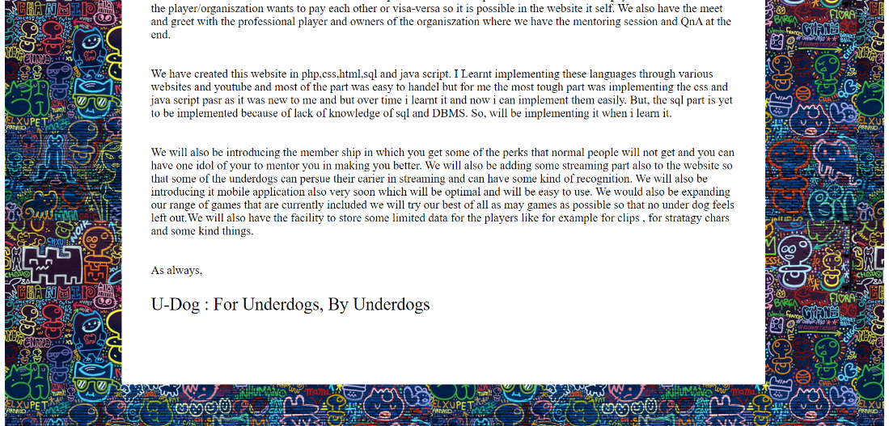

**Blog Page**

**Application : It can be used by players . It can be used by organization. It can be used by non-profession and professional players. It can be used to know the upcoming challenges that the players can face against each other by knowing each other. And many more application.**

**Conclusion : I learnt how to work with Html, CSS , PHP and Java Script. It helped me a lot to understand how a website works.**

**References : None.**